NAME:GOPALA SHASHANK REDDY
ROLL NO: 2404A51447
BATCH NO:17
N.1:
PROMPT:
We need to compute the sizes of directories based on the files and subdirectories listed. The size of each directory should include the sizes of its child directories/files.
CODE:
INPUT:
def compute_directory_sizes(entries):
from collections import defaultdict

# Parse input into a list of (path, size) tuples
dir_sizes = []
for entry in entries:
path, size = entry.rsplit(' ', 1)
dir_sizes.append((path, int(size)))

# Aggregate sizes
total_sizes = defaultdict(int)
for path, size in dir_sizes:
parts = path.strip('/').split('/')
# For each parent directory (including itself), add the size
for i in range(1, len(parts) + 1):
parent = '/' + '/'.join(parts[:i])
total_sizes[parent] += size

return dict(total_sizes)

# Example usage:
entries = [
"/a 10",
"/a/b 5",
"/a/c 7"
]
result = compute_directory_sizes(entries)
print(result)
OUTPUT:
{'/a': 22, '/a/b': 5, '/a/c': 7}
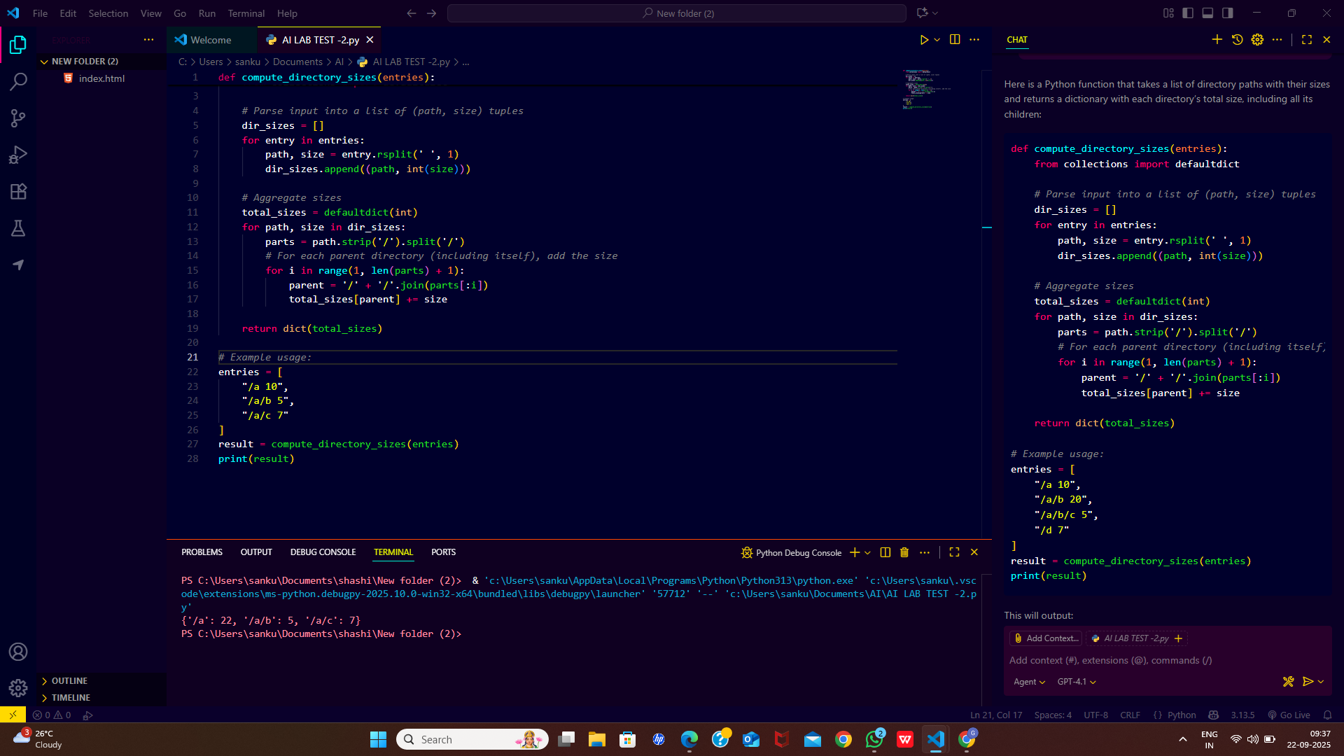

N.2:
PROMPT:
We are given a text and need to compute a sentiment score based on a predefined lexicon:
- good = +1
- great = +2
- bad = -1
We need to tokenize the text, strip punctuation, and sum the sentiment scores of the words.
CODE:
INPUT:
import string

def sentiment_score(text):
lexicon = {
"good": 1,
"great": 2,
"bad": -1
}
score = 0
for word in text.split():
# Strip punctuation from each word
clean_word = word.strip(string.punctuation).lower()
score += lexicon.get(clean_word, 0)
return score

# Example usage:
text = "This is a good, great day but not bad!"
print(sentiment_score(text))

OUTPUT:
2
